
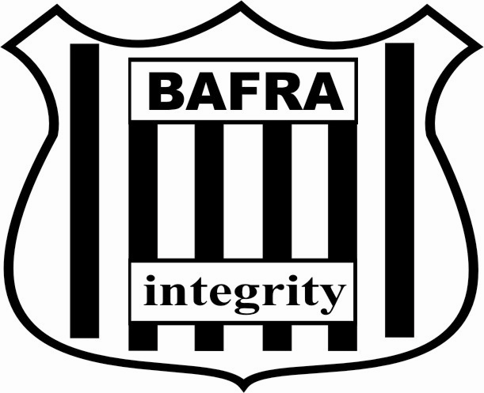

So, you want to be involved but…
Did you ever notice that during a game of American Football, there are actually three teams on the field? If you enjoy this fantastic sport, then officiating could be for you!

Who can be an official?
Just about anyone at least 18 years old can join the ranks of the men & women in black & white. Whether you’re passionate about the game but not keen on kitting up, someone who’s going to be on the sidelines anyway, a retired player or coach, or a college league player who’d like to stay involved during the summer leagues, involvement is a lot more accessible and more rewarding than you might think. A great way of keeping you active and of engaging those grey cells just a bit, officiating keeps you active and looks brilliant on the CV!

How do you become an official?
We really won’t let you go onto the field unprepared. Training consists of a step-by-step induction to enable you to officiate: we help you understand where to stand and what to look for. We allocate new officials to a game where an experienced official will 'buddy' you, giving you the necessary tips on how things are done. The first ten games are monitored closely by your crewmates on the field, enabling you to develop and to gain confidence in officiating this fascinating sport. Since officials work together as a crew (usually of 4 or more), you are never alone.
“But how can I learn all those rules?” we hear you cry! Even though the Rule Book is a lengthy document, it can be digested in easy chapters, and as you gain game-experience in officiating, you not only learn it but also understand it!
BAFRA meets the cost of training, including Rule Book, Mechanics Manual, necessary paperwork and insurance; your first game fee earned is paid directly to BAFRA to help offset this.

What is BAFRA?
The British American Football Referees' Association was founded in 1984 to provide officials for the then fledgling sport. Each year, we train and schedule officials to cover several hundred games at all levels nationally, including senior (over 18), college and youth games. Through the International Federation of American Football (IFAF), BAFRA also provides officials for tournaments on the continent. BAFRA's Elite Programme meets the need for ongoing development and training, should you wish to take it to a higher level.

What happens next?
One of BAFRA's Training Support Officers will get in touch with you to plan your training. Usually an experienced official will be appointed to guide you through it. This can be through one-on-one face-to-face contact, or through a group training session, according to demand.
We operate two seasons a year: the BAFL and youth leagues run from April to September; the college league runs from October to March. While most officials work in both, it is possible to tailor your officiating to your availability and level of commitment. We also need officials to cover flag football tournaments during the summer.
You can decide your own level of involvement in the Association as you go along – the Director of Operations will assign you to games as and when you are happy to work them. Furthermore, membership covers you for insurance on the field. You will normally be paid £25 for each of your first 10 games (after the first two game fees paid directly to BAFRA to help offset this), and, once qualified, will receive £45 per game. BAFRA pays travel expenses for longer journeys.

For more information:
- Talk to the officials at a game
- Go to www.bafra.info

